THE FIRST ENGLISH
E N I G M A
MAGAZINE IN OUR TOWN
M A G A Z I N E 
Š U R A N Y
---------------------------------------------------------------------------

Were you waiting for this summer holidays?
….I suppose all of us! But especially our children.
We can give you some tips how to spend long summer days in Šurany and its surrounding.
Activities for adults:
- to watch some good films at the cinema
- to go to the sport facilities
- to go to the town library / watch out the time is changed/
Activities for children:
- to visit The Centre of Free Time Activities
- to go to the town daily camp / contact CVČ /
- to go to the Happy Summer Camp 2011 / Enigma Language School /

Enigma Language School is going to publish monthly magazine in electronic form with a lot of info, jokes, crosswords, presentations, pictures, articles, tasks, photos…
---------------------------------------------------------------------------
2 - July 2011

CONTENT:

COVER PAGE: Presentation of activities in Šurany during summer ´11
PAGE 01: Content
PAGE 02: Summer is here!
PAGE 03: The end of the school year in Enigma
PAGE 04: Summer in our town Šurany
PAGE 05: Summer in our town Šurany
PAGE 06: Summer in Enigma
PAGE 07: Summer in the world
PAGE 08: Travelling
PAGE 09: The smallest kids´ page
PAGE 10: Young reders´ page
PAGE 11: Teens´ page

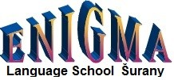

__________________________________________________________
1
S U M M E R I S H E R E!
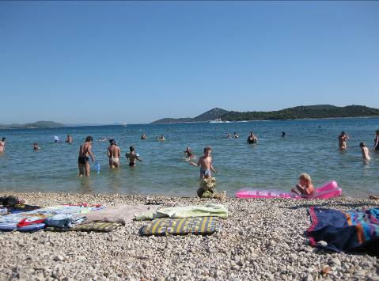

All of us are looking for the long summer holidays. To make this year´s holidaysreally happy and lucky, keep in mind that there are some dangers in the summertime.

1. Sun - use sun creams, sun glasses, drink plenty of water and try to keep yourself cool

2. Dangerous insects - be carefull about small insects, ticks and mosquitoes

3. Food - wash all the fruit before eating it and you should prefer cooked food

4. The pool - do not swallow or drink pool water, everytime shower with the soap afterwards

Have a nice summer holiday!

__________________________________________________________
2

T H E E N D O F T H E S C H O O L Y E A R

2 0 1 0 / 2 0 1 1

….finally the gates of the schools in Slovakia are closed and we can relax, spend holiday with our friends and families. We think that every child makes a lot of fun, visits different places, meets new friends and is going to swim as much as possible.

The end of the school year was a kind of special event in Enigma, too. The children received their Final Certificate. On the Final certificate they the level they participated during the school year and we evaluated their skills such as speaking, listening. Reading and writing for movers were added. We and their parents had an impression that they liked this form of evaluation very much.
Of course, the children received chocolate bar and a bagde which they put on Enigma schoolbags.

A month ago on 1st June there was very important day for all children in the world. It was the Internationl Childrens´ Day. We celebrated this happy day in Enigma Language School, too. One of our parents bake again, this time lovely muffins which presented the faces of various animals. The children really love it, they could choose the face of the animal they liked the most. Here are some photos of this special day.
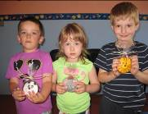
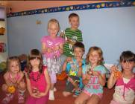
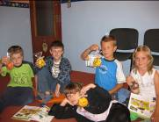
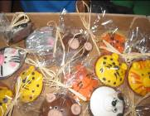
Anyway, thanks Erika Sucháňová for muffins !

__________________________________________________________
3

S U M M E R I N Š U R A N Y

GENERAL INFORMATION

The members of the town Šurany passed the final account of the town for the year 2010. The Majer of the town informed the inhabitants that the year 2010 was the year of reducing all the finances that the town had available. As far as we all know the year 2010 was characterized as the year of economical crisis in the world.
This year the situation is similar. We have to save in all the departments in the same way as before. The Major said that the town received only 43% of all money from the state for the month May 2011 and 38% in June. The Ministry of Finance suggested to all the towns and villages to raise taxes for inhabitants for 50%. Alhough the town Šurany raised the taxes for 10% last year, we are informed so far that raising 50% for taxes is not prepared at the town at the moment.

CULTURAL EVENTS

The Church Reconstruction

In the past the town had already help to reconstruct the towers of the Catholic church and nowadays the town help again to reconstruct the other part of this church.

The Beginning of precaution against the high water

The town wants to continue to build higher edge of river banks. People also clean the river surroundings. They still remember the situation which was in Nitriansky Hrádok last year. The town wants to reinforce and raise about 40 centimetres the edges of the banks from Tenký Háj to Nitriansky Hrádok.

__________________________________________________________
4

SPECIAL SPORT EVENT

80s´ Anniversary of the football team in Šurany

There is no doubt that football is the most popular game in Šurany. In these days the football team celebrates 80 years from the establishing it. For this special sport events were prepared friendly football matches at the football stadium, good music, refreshments…and of course sporting mood of football funs. As a present the town and the football team got the present from Jozef Šutka. It is a book which was published shortly before this event. It is called 80 years of organizing football in Šurany. He collected a lot of information even from abroad and he described the whole progress of the football team in Šurany from the early beginning up to nowadays.

__________________________________________________________
5
S U M M E R I N E N I G M A

We are happy to spend beautiful time during this summer holiday. People like going to the swimming pools, by the sea, to the camps. Kids love water, they play a lot of games, have a lot of fun.
….anyway we can advise you how to spend sunny days in Šurany and its surroundings.
Enigma Language School prepares HAPPY SUMMER CAMP for kids of our school. The camp is for week form 1.8.2011 - 5.8.2011. We start every day at 8.00 and finish at 16.30. We use English for about 5 hours/day. The children are going to visit different places around Šurany.They are going to meet some interesting people, to have a lot of fun, to do many activities, to compete a lot, to see animals to have barbecues…
Our aim is to show the children that they can study English in the funny way throughout the quizes, competitions, games, even children are going to learn how to cooperate with the others in the team work. For the further information you can contact enigmasurany@gmail.com or to look at our web info.
We hope to have a lot of very nice experiences and fun together.

Enigma offers you a year standard courses of English language since september.

! You can contact us from 22.8.-2.9.2011 from 16.00-18.00 !

Our advantages are:

- we teach English such as the mother tongue
- we teach through the games, movements, drawings, singing...
- we have the most 7 people in a group, the youngest are 5 people
- direct communicative contact several times in a lesson
- beautiful area in the silent part of Šurany, garden is avaliable
- new multifunction study room with new technologies for studying

Enigma is your gate to the world!

__________________________________________________________
6
S U M M E R I N T H E W O R L D

Holiday types

Beach holidays

Family holidays

City breaks

Romantic holidays

Luxury holidays

Winter sun holidays

Golfing holidays

Ski holidays

Restaurants & bars

Spa hotels

Shopping trips

Nightlife

__________________________________________________________
7

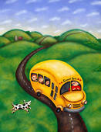
T R A V E L L I N G

M A R C H E N P A R K

Last month we informed you about the trip in Budapest in Tropicarium. In June we decided to organize the trip to Marchenpark in Austria. It was on 4th June 2011, we arrived to Marchenpark at 10.00 o´clock and we enjoyed everything that was offered to us. There were some wild animals, fairytale wood, farm with domestic animals and tractors,water land and a lots of roundabouts, restaurants and the other attractions for children, The weather was excellent, the sun was shinning all the time so the childrenspend some time in the water too. I Marchenpark there were about 78 attractions.

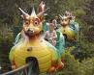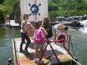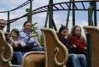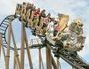

!!! OUR PHOTOS ARE ON www.enigmasurany.webnode.sk !!!

__________________________________________________________
8
The Smallest Kids´ Page

1. Count the numbers!

…………. football …………stars

2. Colour the picture!

blue bird red cushion

3. Finish my body!


- blue eyes
- orange nose
- red mouth
- small ears
- green arms
- yellow legs

__________________________________________________________
9
Young Learners´ Page

1. Colour the pictures!

red chair blue chair and red table green bed

2. Count the numbers!

………… icecreams ………… biscuits ………..apples

3. Colour the animals!

___________________________________________
__________________________________________________________
10
Teens´ page

1. Clothes items!

2. Name these things!

3. Sport activities - write them to the correct box!

football, tennis, skiing, skating, running, hockey, windsurfing, bodybuilding, handball, sailing, swimming, diving, chess, snowboarding, basketball, jumping

INDOORS | OUTDOORS

__________________________________________________________
11
BYE - BYE

SEE YOU THE NEXT MONTH!

